Tode-SIOST
Owners Manual

Tode Side-IO Screw Terminals [ #SIOST ]

by TGit-Tech [ http://www.tgit-tech.com ]
Build Version: 231T / Last Updated: 2023-01-29

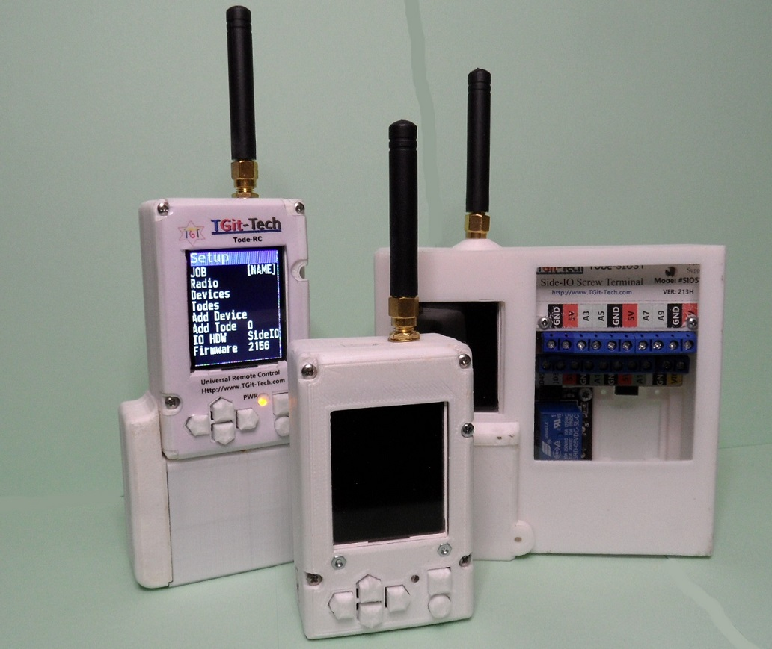

Table of Contents
1. Introduction 2

Introduction
